**Ideation Phase**

**Traffic Telligence: Advanced Traffic Volume Estimation with Machine Learning**

|  |  |
| --- | --- |
| Date | 31 January 2025 |
| Team ID |  |
| Project Name |  |
| Maximum Marks | 4 Marks |

**Traffic Telligence: Advanced Traffic Volume Estimation with Machine Learning& Idea Prioritization Template:**

Develop a machine learning-based system to accurately estimate traffic volume using multimodal data (e.g., video feeds, GPS data, mobile network signals, and road sensors). The goal is to help urban planners, transportation authorities, and smart city developers make better traffic management decisions.

**Reference Link:**

https://www.slideshare.net/slideshow/traffic-prediction-for-intelligent-transportation-system-using-machine-learning/25225005

**🎯 Step 1**: **Real-time traffic volume estimator**

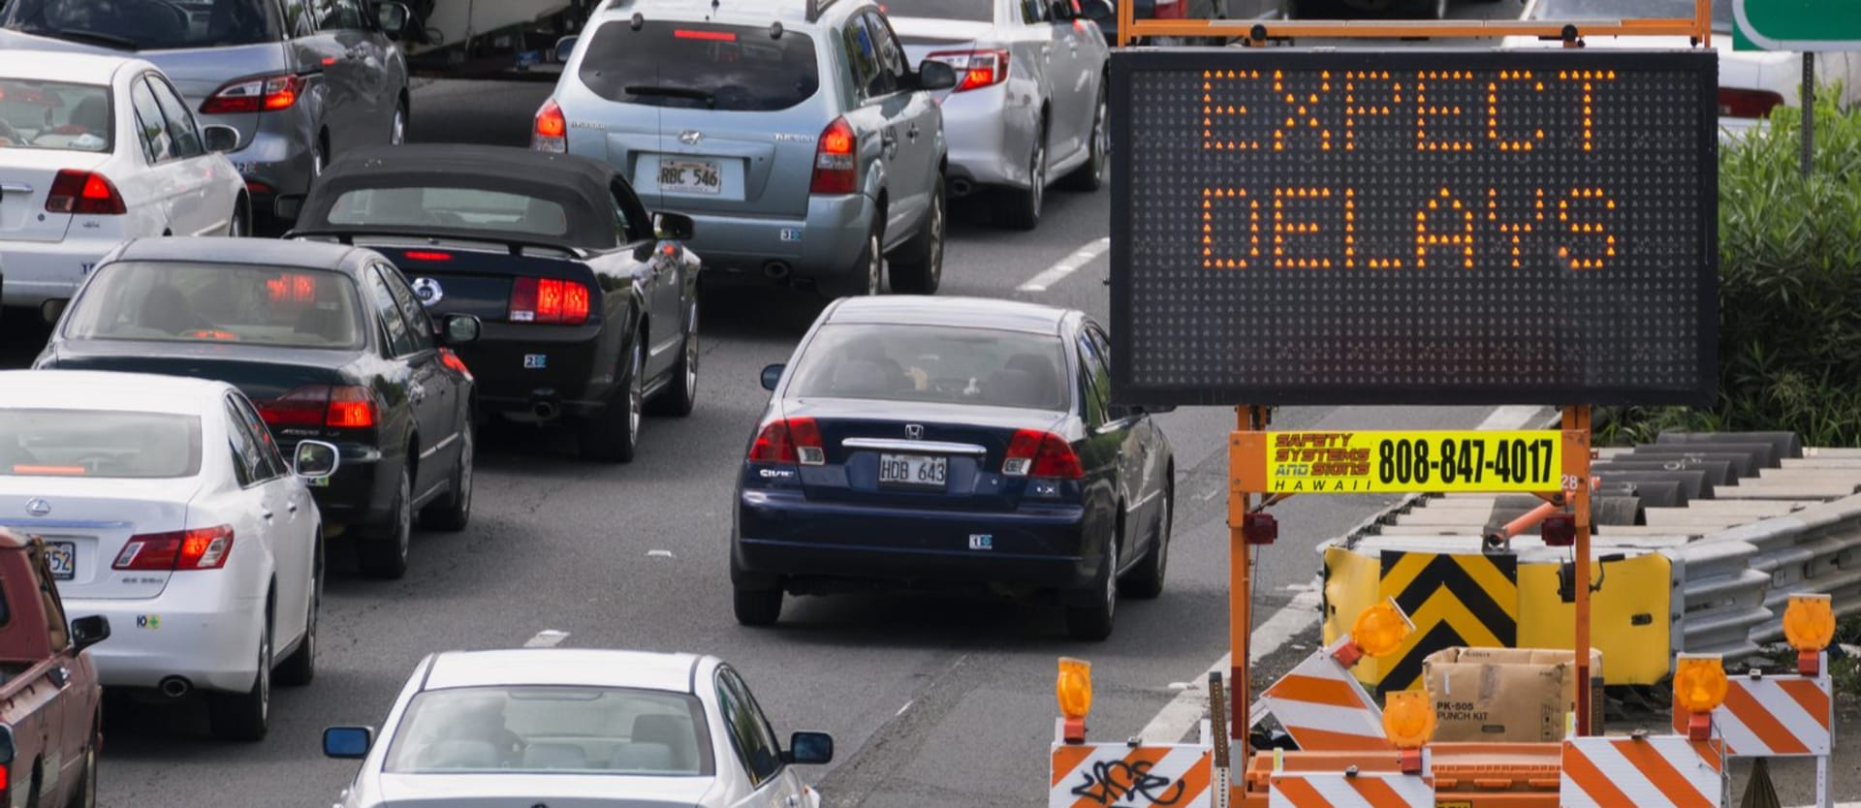

**📈Step 2: Define Evaluation Criteria**

**Standard Criteria:**

| **Criterion** | **Description** |
| --- | --- |
| **Impact** | How valuable is this idea to end users or the success of the project? |
| **Feasibility** | How easy is it to implement with current tools, data, and resources? |
| **Cost** | How expensive will it be in terms of resources, compute, or licenses? |
| **Time** | How long will it take to implement (weeks/months)? |

**Rating Scale:** 1 = Low, 5 = High

**📊 Step 3: Create a Table**

**Use this table format**:

| **Idea / Feature** | **Impact (1–5)** | **Feasibility (1–5)** | **Cost (1–5)** | **Time (1–5)** | **Priority Score = (Impact × Feasibility) - (Cost + Time)** |
| --- | --- | --- | --- | --- | --- |
| Real-time traffic estimation (video) | 5 | 3 | 4 | 4 | (5×3) - (4+4) = 15 - 8 = **7** |
| GPS data integration | 4 | 4 | 3 | 2 | 16 - 5 = **11** |
| Dashboard visualization | 4 | 5 | 2 | 2 | 20 - 4 = **16** |
| Traffic prediction (future volumes) | 5 | 3 | 3 | 3 | 15 - 6 = **9** |